Work Creation Configuration
Overview
The Work Creation configurations created which determines the system generates work, based on the values that you established on other work creation configurations.

Configuration Hierarchy

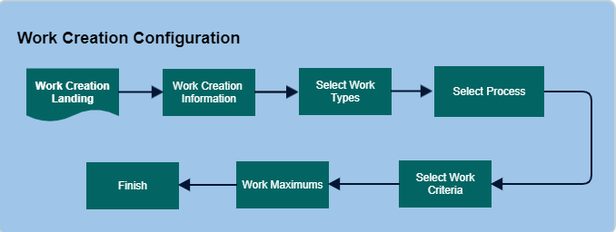

Configure Work Creation Records

1. Work Creation Information

- Work Unit Field - Select the value that will identify each work unit generated for this work creation master. For example, if the value ERP Order is defined, when a work instruction is generated using this record, the ERP order number is displayed as the instruction number. The default work unit value is defined on the Work System Values Window.
- Creation Method - indicate if the system will use this master to generate work. To use this master to generate work, select the Pre-Build Option. The system will generate work using this master (during the wave cycle). To prohibit using this master to generate work, select the Inactive Option. In this case, the system will not refer to this master during work creation.
- Priority - Identify when this master should be selected during work creation, in relation to the other work creation masters. During the wave, the system cycles through work creation masters in priority order. The lower the priority number, the sooner the master will be used: the master with priority 1 is processed before the master with priority 2.
- Auto Print Documents - If the pick documents should be printed as soon as they are generated. If you select this checkbox, the system will print the documents as soon as the work creation step is completed. Note that if you select this checkbox AND the pick list document type is defined in a document master record, the system might generate the pick lists twice: first after work creation runs and second after paperwork runs. This will give you two sets of pick lists generated during one wave cycle.

2. Select Work Type

The selected will associate a work type with this configuration. The work type links this configuration to the eligible work profile records. A work profile manages who is assigned to process the work.

3. Process Information
- Process - Identify which work creation process this master is for. During creation, the system will reference particular database tables based on the value that you define here.
- SRC Identifier - Associate the configuration with the appropriate SRC identifier. System will use the configured SRC identifier during work creation and update the work created with the SRC identifier from the work creation master. This can be done for all work created in the system except cycle count. For cycle count, we need to define the SRC identifier in Cycle count system values.

4. Work Criteria Record
Associate this master with the appropriate work criteria. This value determines which work requests will be processed using this work creation master. It also determines how the work instructions will be organized. Note that if you complete this step after you define a value in the Process Field, the system will only allow you to select criteria values for that particular process.

5. Work Maximum Information
This screen is used to set maximum capacity rules for a work unit. It includes maximum values for quantity (number of item units), weight, volume and instructions. As the system is creating a work unit, it will reference the values defined on this tab. As soon as it reaches the limits defined here, it will close the work unit and generate a new one. You can use any combination of these fields to define the maximums. If you define multiple maximums for a record, the system will close the work unit as soon as it reaches any one of these maximums.
Note: that the system will not split a detail record as a result of the value exceeds the maximum in and of itself.
- If you want to create a record with no maximums, leave the '0' value in all fields. If you leave the Maximum Instruction Field value '0', the system will include up to 500 instructions in a work unit. If more than 500 instructions can be processed using this creation record, the system generates additional work units to support the remaining instructions.
- All of the maximum values can be applied to the following work: shipping containers, allocation, replenishment, work order line, and work order for finished items.
Cycle Count Work Note: Only the maximum number of instructions value can be applied to cycle count work.

Work Profile Configuration
Overview
A work profile is a set of rules that define how work is done in the warehouse. Each rule is made up of one-to-many sequence records that define how work is initiated and completed.
- A work profile can have multiple sequence rules, which are executed in order (for example, 10, 20, 30, etc.).
- When there is no more work for a sequence rule, the system moves on to the next one.
A sequence rule specifies various work parameters, such as:
- The work types that can be done in this sequence
- The work initiator: user or system
- The sequence of picking and putaway instructions assigned by the system

Configuration Hierarchy

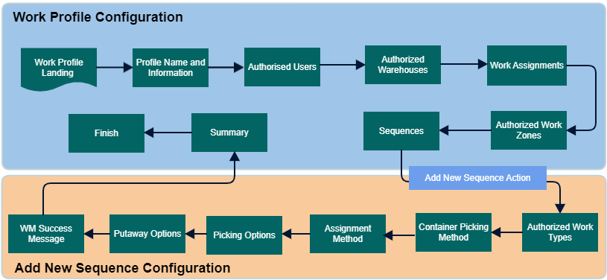

Configure Work Profile

1. Work Profile Information
The work profile information includes Name and Description

2. Authorized User
Select the users who will process work based on this profile.
3. Authorized Warehouses
Select the warehouses to which this work profile has access.

4. Work Team
A work team is a group of individuals that share the following characteristics: shared work zones, shared equipment types, and/or shared work profiles. To minimize setup time, you can create work teams for groups of employees, instead of creating individual user profiles for each employee. During work execution, the system will assign work to teams, based on the values that you establish on the work team record.
5. Work Assignments
Select Work team and Equipment type from the drop-down list. Select the team(s) and equipment type(s) that will process work based on this profile.
6. Authorized Work Zones
Select the work zone(s) that users will be able to execute work from while using this profile.

7. Work Profile Sequences records
Using sequence, users can configure a Work Profile Sequence Record.

Add new Sequence
Users can select an existing sequence record and add a new record. New Work Type wizard is displayed. Read Work Type for more information.

Work Special Handling Configuration
Overview
A work special handling configuration record defines processing validations or restrictions required for a specific group of work instructions. You can use these configuration to increase security for expensive product, support a customer account's requests, provide guidelines for new employees, and minimize errors occurring in specific warehouse zones.

Note: These work special handling constraints are only reflected in Warehouse Mobile or RF work processing and will not work in Work Insight Screen.

Configuration Hierarchy

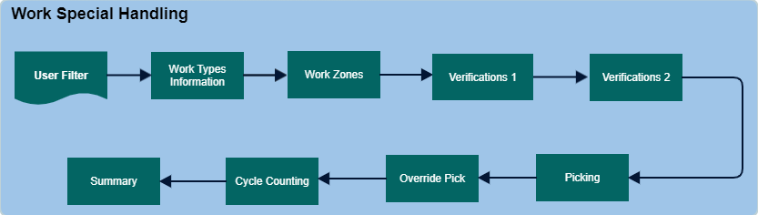

Configure Work Special Handling

1. Select User
Select the user for which the work special handling constraint will be configured.

2. Work Types
In this screen select a specific type of work, such as order picking. You will define your warehouse's work types on the Work Type Window. Warehouse work type is selected. These work type selected will be associated with work creation records and work profiles. All work created in the system is assigned a work type.

3. Work Zones
This field identifies a group of locations where the same job function is performed by a specific employee or group of employees.

4. Verifications (1)
These settings are used to determine if the user will need to verify item, quantity, license plate, lot, or location during work execution processing. When verifying location, you can have the user be required to enter either the location's ID or its check digit.

5. Verification (2)

Receipt Putaway verification
This setting determines how the user interacts with the license plate when executing receipt putaway work.
- Existing License Plate (No Override Allowed): the system will show the existing license plate ID in display mode, and not allow you to enter a new value.
- Verify Existing License Plate - the system will require you to enter the existing license plate ID for confirmation. An error will occur if you enter a new value.
- Existing License Plate (Allow Override) - the system will show the existing license plate, and you can either use the existing license plate or enter a new value.
- User Specified - the system will not show the existing license plate. Therefore, you will have to enter a new value.

Shipping Container Verification.
This setting determines whether or not the user will need to verify containers when executing shipment work
- None: The system will show the container ID in display mode (no additional user verification needed). Note that if the user partial picks the quantity, they will have to scan the container ID for the next instruction.
- Container Verify: The system will require the user to correctly verify (by entering or scanning the ID) the shipping container that is being picked into.
- Container Spot Verify: The system will require the user to correctly identify the shipping container's spot on the picking cart. Note that this setting is only valid when using group user picking (otherwise the system ignores it).
- Allow Override: The system will default the container ID in the field, and the user can change this value if desired. The system then would validate this new ID to make sure that it does not already exist.
For more information read Shipping container verification page.

6. Select Picking Options
The following picking options affect how the user can interact with work instructions during picking.

- Allow Splitting Of Container - Defines whether or not, you will be allowed to split off and pick a portion of the quantity into another container. To accommodate this action, the system will create a new work unit and container for the split quantity. This is helpful if the container that you are picking into gets full before you are done picking the current quantity. Typically this situation would occur if you created containers in the wave, and the current pick physically will not completely fit into the container that the system created for it.
- Allow Over Picking - Allows the user to pick more quantity than exists on a work instruction, as long as this quantity is within the location's available quantity. When an over pick is performed, the system will increment the transaction quantity, and process the pick as a complete/normal pick. This option is only available for RF replenishment and work order picking. For example, suppose a work order component work instruction calls for 980 eaches of an item. It may be easier physically, then, for the worker to pick two cases of 500 (for a total of 1,000 eaches) rather than breaking one case open and leaving 20 eaches loose at the location. If this checkbox is checked, the system will increment the instruction by 20 eaches, and process the pick as normal.
- Allow Pick In Transit - Allows the user to pick in transit quantities. If there is not enough quantity in the location to be picked but there is additional inventory that is 'on the way', this allows the user to pick from what is coming or 'in transit'. If the inventory is picked against what's in transit, the inventory will show a negative quantity.
- Close After Partial Pick Checkbox - Allows the user to partial pick the quantity of a work instruction, and the system will delete the remaining quantity from the work instruction. The system will then close the work instruction. Therefore, the remaining quantity will never actually be picked. For example, suppose you have a replenishment request that calls for 620 eaches of an item. The user, however, may only want to pick 600 eaches of the item (because that is a more round number in regards to how things are packed), so they just want the other 20 eaches to “go away.” If this option is checked, the system would delete the remaining 20 eaches from the work instruction (after the user picks the 600), and close the work instruction.
- Replenish On Outbound Short Pick - Indicate that when the user short picks an item quantity at a location, the system will attempt to run replenishment (based on the location's item demand resulting from the short pick). If there is enough In transit quantity that is on its way to the location for this item, then the system will display to the user a message asking whether or not they want to continue with the short pick.
- Maximum Pickup Quantity - The maximum number of units that can be picked at one time. When the employee is picking the product, the system will require him/her to only pick the amount displayed here. If the work instruction requires more than the value defined here, the system will ask the user to pick this amount as many times as required to fulfill the work instruction. This constraint increases the likelihood that the employee will count the product.
- Use Converted Quantity - This setting is used for workers who do not pick in the base UM and pick in either cases or pallets. If the user is not picking any item in eaches and always picks in an UM which is not the base UM, then the picks should also happen with the converted quantity (CS, PL etc.). For example, if 1 CS= 10 EA and a user picks 2 CS, the converted quantity is 20 EA.
The system uses the converted quantity as the main pick quantity value and the base value as the secondary read-only values when the pick quantity is a multiple of the converted quantity. If the pick quantity is not a multiple of the converted quantity, the system uses base quantity UM as the pick quantity. Also, the system updates work, inventory, shipment, and transaction history correctly based on converted UM quantity picks.
- NOTE: User cannot enter a decimal quantity for the converted quantity to a partial/short pick.
Container Creation During Pick
- Prompt for Quantity -You can use this setting to perform Inline Partial Pick for Container Creation During Pick. The system will prompt with quantity field to enter the partial quantity.
7. Override Pick
The following override pick options are available during the picking process. Override Pick can be performed for outbound (allocation and shipping container) work, replenishment and inventory transfer work.
Read Warehouse Mobile - Override Pick.

8. Select Cycle Counting Work Options
These settings determine specific behaviors when executing cycle counting work.

License Plate Selection Method -This setting indicates how you want to handle license plate cycle count work:
- System Initiated: This indicates that the system will tell the user the order of the license plates that they are required to cycle count.
- User Initiated: This indicates that the user will be able to specify which license plate that they want to count.
Count Level - This setting indicates exactly how/what the user will perform a cycle count at a location when executing cycle count work
- Standard Count: The user will count the individual cycle count(s) present for the location.
- Blind Count: As in a standard count, the user will count the individual cycle count(s) present for the location. However, the system does not present any information on screen *except* for the location ID. Therefore, the user is forced to count each item that is physically present in the location without the system guiding them in what should be counted.
- Count License Plates: The user will count the number of license plate(s) that are currently present at a location. For example, suppose a certain product is housed in a second story location. Since users would not be able to easily access and count the quantity contained in these license plates, you could configure counts for this product to ask for the number of license plates present at the location, rather than a count of the actual quantity. Note that if a license plate count differs from what the system expected, the system will require the user to count the actual quantity contained per license plate. Also note that multi-item locations always force the user to count individual quantities (even if you have this setting selected on your work special handling).
- Group Count By Item/Company: The user will count all of the quantity at a given location for the same item/company (regardless of the lot ID, inventory attribute, and/or license plate values):
  - If the user's total-quantity count does not meet the system's total-quantity count, the system will ungroup the cycle count work and display an error message. If you are cycle counting multiple items at the same location OR an empty location, then you will have to confirm the counts individually (even if this setting is enabled).
  - If you choose to add an item when confirming a grouped count, the system will ungroup the cycle count work and you will need to confirm each count individually. Note that after you add an item, the system will give you the option to continue with the add item action, or to return to the group count.
  - If this setting is enabled AND lot/license plate verification is enabled, the system will ungroup the cycle count work and you will need to confirm each count individually.

Add License Plates During Cycle Count - This setting determines if you will have the ability to identify a new license plate to the system when performing a cycle count for a location.
- This setting is only available when you are using a License Plate Selection Method of user initiated.
- When the user attempts to add a new license plate, the system will reference the user's cycle count preferences
  - If the license plate falls within the user's positive tolerance, then the system will add to the location the new license plate/item quantity.
  - If the license plate falls above the user's positive tolerance, then the system will set the count of this location to pending review.
- You can have the system set all counts that involve new license plates to a pending review status using the Set New License Plates To Pending Review
- The system will ignore this setting if you have the ability to add items during a count. Since you are always allowed to add license plates when adding an item to a location's count, this setting is not recognized.

Set New License Plates To Pending Review - This setting indicates that you want the system to place in a pending review status all cycle counts that involve new license plates created by the user (while executing counts). A warehouse supervisor then will have to review the count before it is made official in the system. This option is only available when you are using a License Plate Selection Method of user initiated.
NOTE: The system will ignore this setting if you have the ability to add items during a count. Since any new additions during counts is automatically put into a pending review status, this setting is not recognized.

Group Picking Work Sequence
Group Picking Work Sequence determines the order in which work units within a picking group are executed, aiming to maximize efficiency. When work units are assigned to a transport container, the system uses this configuration to decide the optimal picking sequence.

- Sequence - Determines the processing priority (lower numbers are processed first).
- Order By Field to indicate the order you want the system to process though your sequence records.
  - Ascending: Choose this option if you want the work units to be processed in ascending order.
  - Descending: Choose this option if you want the work units to be processed in descending order.
- Attribute Field to indicate what value you want to sequence work units by. For example, you could choose to sequence the work units by From Location, which would allow you to pick all of the item(s) that reside in the same location first.

Work Group
A Work Group categorizes similar activities that help move products through the warehouse. Examples include Receiving, Picking, Packing, and Shipping. Each work group can encompass multiple related Work Types.
For instance, “Order Picking” and “Batch Picking” are work types under the broader “Picking” work group.

Work Type
A work type is a specific category within a broader work group, defined by its processing characteristics or operational needs. For example, batch picking is a type of work that falls under the general picking work group. In this case, the work type "batch picking" identifies all picking tasks that are best handled in batch mode.
The system includes several predefined work types, such as batch picking and order picking. However, you can also create custom work types tailored to your business processes. These custom types can later be used to define processing rules through the Work Profile configuration.

Create work Type
- Work Type- Enter a unique name for your new work type.
- Description- Provide a brief description of the work type.
Note: For Vocollect processing, this description acts as a numeric identifier used in voice communication.
- Labor Type - Specify the type of labor management record that should be generated for this work type.
- Labor Group - Select a group of users who perform similar functions related to this work type.
- Transaction Count Description - Define the label for a custom field that appears on the Manual Labor Entry Screen. This label will be paired with a numeric input field.
For instance, if you create a work type called Sweeping Floors, and set the Transaction Count Description to Aisles Swept, the janitor can then log how many aisles were cleaned during a given time period.
- Work Group - Link your work type to the appropriate overarching work group.
- Default Priority - Set a priority level for tasks associated with this work type.
  - A user’s Work Profile includes a From Assignment setting, which controls how tasks are sorted. If this setting includes a priority-based sort (e.g., Priority/Location/FIFO), the system will use the priority defined here.
  - Note: Priority values are only applied when work is assigned through system-directed mode using an RF device. Manual (full-screen) task assignment does not support priority-based sorting.
- Pick Management Active - select toggle button to make the work type available in Picking Management windows.
To be eligible for display in these configurations, both this toggle and the From Work Zone field in the work instruction must be defined.

Authorized Work Types
Select the work types that set the which work instructions will be processed using this sequence.

Work Initiation Method
Work Initiation Method to indicate how the work will be assigned to the user.
- User initiated: The user selects which work he/she will process.
- Cart Picking: User picks product into containers/totes assigned to a cart.
Container Picking Method
These settings are used to determine whether or not you are picking product into a shipping container or tote.
- Pick Into Shipping Container - Users will be able to directly pick into the final shipping container.
- Pick into tote - Users will be able to directly pick into a tote (transport container). Also, users can pick multiple shipment lines going to different putaway locations into a single tote.
- Sort Picked quantity - This option is enabled only when Pick to Tote is selected. This is selected for Putwall sorting operation.
Assignment Methods

From Assign Method

This determines how the system will assign work units using system-directed work initiation.

Priority/Location/FIFO - The system assigns work based on priority: the lower the priority number, the higher the urgency. This way, the most important customers are handled first.
- If the multiple pick instructions share the same priority, the system will assign the instructions in location order: the location closest to the user is assigned first.
- If multiple pick instructions share the same priority and location, the system will assign the instructions in FIFO. The first instruction generated during work creation is assigned first.This can minimize travel time.
Location/Priority/FIFO- Work is assigned based in location proximity order: the location closest to the user is assigned first. This minimizes travel time.
Note: the system only recognizes number proximity in ascending order. In other words, if location 999-999-999 is physically next to 001-001-001, the system cannot recognize the distance between the locations.
- If multiple pick instructions share the same location, the system will assign the instructions in priority order: the lower the priority number, the sooner the instruction is assigned.
- If multiple pick instructions share the same location and priority, the system will assign the instruction in FIFO order. The first instruction generated during work creation is assigned first.
First In, First Out (FIFO) -All work is assigned in the First In, First Out order. The first instruction generated during work creation is assigned first.

To Assign Method
This determines how the system will assign putaway work instructions using system-directed work initiation.

- LIFO - All putaways are assigned in the Last In, First Out order, which means the last item picked is the first item put away.
- Location - All putaways are assigned in location proximity order: the putaway location closest to the user is assigned first. This is commonly used if you are processing product in a bin or other unorganized structure.
Picking Options
The following settings determine various behaviors during picking
- Default LP id as container ID on full picks - This option is used to indicate that you want the system to default the location's license plate ID (from which you are picking quantity from) as the container ID of the shipping container that you are picking the quantity into. Note that you can enter a different container ID as well, this license plate ID is only defaulted into the field (its use is not mandatory).
- Group picks by loc/LP- This checkbox is used in Warehouse Mobile picking, to indicate that if a work unit has multiple picks for the same item at the same location, you want the system to group this into one pick. Click to read more. if you are using the Cart Picking initiation method, the system always attempts to group picks.
- Print at WM Work Start - Indicate that you want the system to print shipping container label(s) when you begin to execute work units via Warehouse Mobile. Note that the system will only print shipping container labels that have the "Start WM Work" print procedure checked on the document type record. Also, the system will only print in this manner if you are executing work that was created from shipping containers.
Putaway Options
The following settings determine various behaviors during putaway.
- Putaway into Shipping Container - This option indicates that you want the user to place product directly into shipping containers during the WM putaway process. Using this option, the system will either create a new shipping container, or add the item to an existing shipping container (whichever is appropriate).
- Automatic Putaway - This option is used to indicate that you want the system to automatically putaway items during the work execution process. This would bypass having to manually putaway each item on a shipment. Typically, this setting would be used when you are picking directly into shipping containers (but you can use it in any work scenario, except dock management work, where it is not supported).
- Consolidation after putaway - This option identifies if you want to invoke the consolidation putaway process after performing a work putaway action on an Warehouse Mobile. Note that if the Automatic Putaway setting is selected, the Consolidation After Putaway setting will not be available to select.
- Nest After Putaway - This option is used in Warehouse Mobile group picking, when you are picking into a final shipping container (only when the work unit is for a single shipment). If you check this checkbox, the system will display a nesting WM screen after you have putaway your shipping containers. If you specify a container, the picked containers are then nested under it. This allows you to do is pick into shipping containers, and then place those shipping containers on a pallet for shipping. Note that the nest after putaway functionality is not supported when performing putaway to shipping container.

Also note that if receipt containers/license plates for these items were created during a wave, the system will group these as well. Suppose that 3 cases are ordered. During the wave, the system allocates the cases from the same location, and the system creates 3 full-case receipt containers/license plates. When a user performs the work via Warehouse Mobile, they will have to verify and confirm only one time for all 3 cases combined.
- Use Cross dock LP id from Receiving - This option indicates whether you want the system to use the license plate from receiving as the container ID when creating a new shipping container on the shipping dock. If this setting is not selected, then the user will have to manually enter a container ID in this situation. Note that this is an optional setting that is only available if you have enabled the Putaway Into Shipping Container option. Note that this functionality cannot be used if there was already a shipping container created for the shipment line during the wave or WM picking.
- Group putaway by shipping container - This setting indicates that you want the system to group putaway instructions by shipping container, when there are multiple putaway locations associated with multiple containers on the work unit. Read More
WM Success Message
Select the WM Success Message to indicate that you want the system to display a text message after each successful pick or putaway. Read Enable Success Text Checkbox

Warehouse Mobile - Cart Picking
Cart picking enables the warehouse associates to pick items by following instructions on the cart picking screen.

Related Topics...
Warehouse Mobile - Sign in
Processing RF Work
System Built Cart Picking Process

Warehouse Mobile screens
- Using Warehouse Mobile - System Directed
- Receiving
- Close Container
- Cycle Count Work
Topics Discussed
- Cart Picking
- Pick to Tote - Cart Picking
- New Cart Type
- Cart Picking Actions
- Remove Containers from Cart
  - Remove a single container from a cart
  - Remove all containers from a cart
- Notes

Cart Picking - Container work
The following details the steps for the Cart Picking. The cart picking container spot assignment is usually have two options.
- User : User can select the spot on which the container can be placed.
- System: System assigns the spot automatically for the container.
Sign in to your Warehouse Mobile screen and select the Work Execution
- Tap Work Execution to view Select Work Profile screen.
- Select cart picking work profile from the menu.
- In the Cart Picking screen. Enter/Scan Container ID and tap Go. The screen displays the Container Type and Container ID details.
- Enter Spot value. Note: Spot is prompted to user when Spot container is selected.
- A success message is displayed on assigning a container.
- Once all the required containers to the cart picking, Go to Actions >>Begin Picking to start picking items.
- In the Pick Confirmation screen, all details such as Work Unit, Location, Item, Description, Container, Spot, quantity is displayed.
- In case you have location or other validations configured, enter them in the field and tap Go.
- Cart Picking success message is displayed.
Pick to Tote - Cart Picking
Users can assign a tote to a cart before the start of cart picking.

Sign in to your Warehouse Mobile screen and select the Work Execution
- Tap Work Execution to view the Select Work Profile screen.
- Select cart picking work profile from the menu.
- In the Cart Picking screen. Enter/Scan TOTE ID and tap Go
- Enter/Scan the Work Unit ID and Tap Go. A success message that the assigning is completed.
- Users can repeat these steps 3 to 5 to enter the assigned tote to work units. When the user has completed assigning the work units, Tap Actions >> Begin pick
- The Begin Pick will initiate the pick and putaway process of the assigned work units. The steps are similar to the User Directed pick to tote work execution.
Put to Store
In case the put to store locations are configured for the work, then the system will pick and putaway the assigned work to the put to store location. Read Put to Store.
- If the Putaway method is configured for Putaway to the container, then after the pick, in the putaway screen, the system will prompt for container ID and container type.
- The system will not prompt for a container type if we scan an existing container ID.
New Cart Type
This functionality is used, when user need to create number of cart pickings. Once user has assigned the containers to the cart, user can skip picking process and go ahead to create a new cart.
- Tap Work Execution to view Select Work Profile screen.
- Select cart picking work profile from the menu.
- In the Cart Picking screen and enter/scan Container ID and Tap Go. The screen displays the Container Type and Container ID details.
- Enter Spot value. Note: Spot is prompted to user when Spot container is selected.
- A success message is displayed on assigning a container. Repeat the process to add multiple containers.
- Go to Actions >> New cart to view Cart Picking screen for new set of container assignment.
Cart Picking Actions
The following are the actions that user can perform from pick confirmation screen during cart picking.

Partial Pick - This enables user to pick a portion of total pick quantity that is set for execution. System prompts user to confirm the partial pick. Select Yes to perform the partial pick.

Pass: Users can completely stop the current instance of work execution. System will prompt a warning based on the Work System value configuration.
- In Work System Value configuration - 50 - Remove container from cart when pass?, set system value to Warn to prompt warning message to user.

Short Pick - This enables user to pick quantity less than full pick instructed. User need to select appropriate reason and tap Go.

Skip- This enables user to move to next cart picking, without completing the cart picking the item quantity for the current instructions.

Remove Containers from Cart
The enables user to remove one or all containers from a cart. When the container is removed from the cart, system deletes group id and spot value from the shipping container.
Note: The work need to be in open state with group id assigned and not assigned to a user.

Remove a single container from a cart
- Tap Work Execution to view Select Work Profile screen.
- Select Remove Cart Container profile from the menu.
- In the Remove Cart Container screen, enter/scan Container ID and tap Go. The screen displays the success message as Container removed from the cart successfully.
Remove all containers from a cart
- Tap Work Execution to view Select Work Profile screen.
- Select Remove Cart Container profile from the menu.
- In the Remove Cart Container screen, enter/scan on of the Container ID that is part of the cart.
- Tap Actions >> Remove All, system will prompt user to select Yes or No.
- Tap Yes to remove all containers from the cart. Success message All Containers removed from cart successfully.
Notes
- In the Work Profile Details configuration, the Work initiation method is selected as Cart Picking.
- Currently the Container picking method is Pick into shipping container is supported.
- When group user work is performed, the system batches the pick quantity across all shipping containers. This improves picking efficiency in the group user scenario.
- serial number tracked items (outbound or inventory) or catch weight tracked items are exceptions to this grouping
- You can directly scan an assigned container to begin cart picking process without the need to select Actions >> Begin Picks. The system prompts user with message to Begin Picks, Tap Yes to move to Pick Confirmation screen.
- Users can enter/scan multiple tote and work units and begin pick.
- Grouping of instructions is supported in the cart picking -pick to tote.
- the system ungroup the batched work instructions if you partial or short pick the work.

System Built Cart Picking - Process
The system directed cart building process enables the application to assign containers created in a wave to a cart when the user initiates the work unit using Warehouse Mobile. This enables the system to include on carts containers that were created after the initial day’s wave(s) have been run. Also, the system tries to assign containers to the cart in an order (configured by zone) that will provide an optimum walking path when the worker picks products into the cart. This improves the picker(worker) efficiency by reducing the picking time against the manually assigned containers to the cart.

Topics Discussed
Configurations
Using Warehouse Mobile - Work Execution
Process Criteria

Configurations
System Build carts need the following configuration.

Work Profile >> Work Processing Tab

Work Initiation method - Select Cart Picking. The following two options are available for the selection
- System-built carts - Select for the system to assign containers to a cart at the time of work initiation
- Cart spots - Define the size of the cart. The value determines the number of spots present in the cart. One container per spot is allowed by the system.
Zone >> Cart Building tab
- Zone sequence - This sequence value enables the system to optimize the walking order for various work zones in the warehouse for the picker. This improves the picking time and efficiency.
Using Warehouse Mobile - Work Execution

- Tap Work Execution to view the Select Work Profile screen.
- Select system build cart picking work profile from the menu.
- The system will analyze the eligible work units, and build the cart assigning a shipping container to each spot.
- The system will next display the Build Cart screen, which will display each spot and what container (ID, type) that is assigned to each cart spot. You then will physically build the cart before proceeding to the next screen.
  - Cart Spot - Value of cart spot
  - Container type - type of container is displayed
  - Container ID - last four digits of the container is displayed.
- When you are finished placing the containers on your cart, tap Go, and the system will display the first work instruction in the Pick confirmation screen. You can then move with the cart to complete picking in the warehouse
Note:
- If there are no eligible work units for system-built carts, the system will display the Build Cart screen with no spots assigned.
- If you press the Back button on the Build Cart screen, the system will return to the Work Profile Selection screen. The cart that the system just built will stay built.

Criteria for System Cart Building
The application uses the following criteria to decide the work/containers that will be assigned to a cart during the work creation process.

1. Priority - The least numbered priority work units are allotted first. For example, priority with value 2 is processed first then with value 10.

2. Minimum and Maximum Work Zone - The work unit header record has the Minimum (lowest ) and Maximum (highest) zone sequence values. The system will take these zones the from locations of the instructions on the work unit.

Note:
- The system will ignore the work units that does not have the Minimum/Maximum zone sequence configured.
- If there is only one work instruction on a work unit, then the Minimum Work Zone and Maximum Work Zone values will be identical.
- Zone sequence value is NULL on the work zone record, the system will ignore that zone when determining the Minimum/Maximum zone values.
3. Aging Date/Time
This value represents the date/time the work was created. The older the work unit is created; it is considered first for cart building assignment.

Processing Picking Management Work
Picking Management is a different way to view and execute the work within the warehouse. Through regular work execution, each work unit must be completed by one user, moving throughout the warehouse and completing all the work for that work unit. Picking management provides a way for work to broken up by zone, and executed by multiple users. The procedures in this topic describe how to execute work in the various screens of the Picking Management module. Note that in order for a work unit to appear in the Picking Management Explorer/Picking Window, the Pick Management Active check box must be selected on the work unit's associated work zone and work type configuration records.

Related Topics...
Work Process Summary
Picking Management Setup Overview
Picking Management Process Diagram
Identifying a Quality Measures Reason Code
Assigning/Unassigning an Instruction to a Team/User
Releasing Work Units
Processing Work
Processing RF Work
Performing a Group Pick (Paper-Based)

Field Descriptions...

Picking Signon Window Fields
Zone

Picking Selection Window Fields
Details Button
First Location
Last Location
New Container
Print Button
Priority
Quantity UM
Reference ID
Ship To Name
Total Locations
Total Quantity
User Name
Work Unit
Zone
Zones Away

Complete Picking Window Fields
Details Button
Locations
Quantity
Quantity UM
Reference ID
Ship To Name
Short Pick Button
Short Picks
Total Quantity
User Name
Work Unit
Zone

Zone Summary Window Fields
- This window appears when you select multiple zones in the Picking Management Explorer, and choose the View Summary right-click option.
Quantity
Total Instructions
Total Locations
Zones

Explorer Window Description
Picking Management Explorer Node/Level Descriptions

Start Picking Window Fields
Details Button
Locations
Quantity
Quantity UM
Reference ID
Ship To Name
Total Quantity
User Name
Work Unit
Zone

Picking Short Pick Window Fields
Company
Item
Lot
Quantity
Quantity UM

Picking Details Window Fields
- This window appears when you right-click a work unit record (in the Picking Selection Window) and choose Open.
Assigned User
Hold Code
Company
Description
Item
License Plate
Location
Parent License Plate
Quantity
Quantity UM
Reference ID
Ship To Name
User Name
Work Unit
Zones

The following is discussed in this topic:
1. Signing/Scanning on to a Picking Terminal (on the Picking Signon Window)
2. Assigning a Work Unit (on the Start Picking Window)
3. Starting a Pick (on the Start Picking Window)
4. Completing a Pick (on the Complete Picking Window)
5. Unassigning a Pick

1. Signing/Scanning on to a Picking Terminal (on the Picking Signon Window)...
To initiate work, you need to first sign or scan on to the appropriate picking terminal. Once you are logged on, you can select a zone from the appropriate picking terminal. You can perform this action on the Picking Signon Window. This window will display all of the zone(s) that are active for picking management.
- Choose the Picking Signon option from the desktop. The system will display the Picking Signon Window.
OR
Right-click a work unit record in the Picking Management Explorer and choose the Scan On option. The system will display the Picking Signon Window.
- Select the work zone that you want to pick from and press OK. The system will display the Picking Selection Window. If you signed on using the "scan on" option, the work unit you selected will populate the Work Unit field of the Picking Selection Window.

2. Assigning a Work Unit (on the Start Picking Window)...
Before a pick can be executed, you need to assign a work unit to a user. The system will display all of the work units (open, on hold, and assigned) in your selected zone in the Picking Selection Window. This window sorts the units in order by zones away, which indicates which zone is currently ready to be picked into the shipping container. You can also see the first and last location that you must pick from, as well as the total quantity you must pick. Note that a user can be assigned to multiple work units.

Work Unit Icon Explanation
Each work unit is represented by a graphical icon. This icon indicates the status of each unit. Below are explanations of what each icon represents:

Represents an open work unit.
Represents a work unit that has a user assigned to it.
Represents a work unit that has been placed on hold.
- Access the Picking Selection Window. The system displays this window after you choose a zone to work in from the Picking Signon Window.

- If necessary, research work unit(s) by selecting a work unit from the record list and pressing the Details Button. The system will display the Picking Details Window. Press OK when finished.

- Select the work unit that has a zones away value of 0. This represents the zone that you should pick from.

- Enter the user name that you want to assign to the work unit.

- Enter the work unit number you want to assign in the Work Unit Field.

- If needed, press the Print Button if you want to print a work pick list for this work unit.

- Press OK. The system will assign the work unit.

3. Starting a Pick (on the Start Picking Window)...
Once a user has been assigned to a work unit, you will need to confirm the that the pick information is correct. You can perform this action in the Start Picking Window. If appropriate, you can unassign a user as the picker associated with this work unit. You can also view zone details from this window.
- Access the Start Picking Window.

- Press the Details Button to view individual work instruction information from the Picking Details Window.

- If necessary, you can unassign this work unit by pressing the Unassign Button. The system will unassign the work unit from the current user and display the Picking Selection Window.

- To start picking, press OK. The system will display the Picking Selection Window.

- Enter your user name and the work unit you want to pick and press OK. The system will display the Complete Picking Window.

4. Completing a Pick (on the Complete Picking Window)...
You can execute a picking action on the Complete Picking Window. This window will appear when you enter a work unit on the Picking Selection Window that has been previously assigned to you.
- Access the Complete Picking Window from the Picking Selection Window.
- Enter a work unit:
To Pick: Press OK; the system will perform the pick action, and close the work unit.
To Hold: Press the Hold Button; the system will display the Work Hold Window. Enter the hold code that you want to apply to the instruction. The value you enter as a hold code will depend on your business practices. The system will display this code on the Work Instruction Window. Press OK. The system will place this instruction on hold. You can release this work unit from the Work Insight Screen. Note that if an instruction is on hold, you cannot perform any actions on it until it is released. Also, the current instruction(s) will not be confirmed.
To Short Pick: Press the Short Pick Button; the system will display the Picking Short Pick Window. Enter the item and quantity data of the item you want to short pick. If the item is lot controlled, you will need to enter the lot ID as well. Press OK. The system will display the Complete Picking Window. Press OK again. The system will display the Quality Measures Window. Enter a reason code for your short pick and press OK. The system will perform the short pick and display the Picking Selection Window.

Unassigning a Pick...
You can unassign a user from an open work unit. This is helpful if for some reason the assigned user cannot perform a pick. A user cannot be unassigned from a work unit if that unit is on hold. You can also unassign a work unit from the Picking Management Explorer.
- Access the Start Picking Window or the Complete Picking Window.

- Select the work unit that you want to unassign and press the Unassign Button. The system will remove the user associated with the unit, and return you to the Picking Selection Window.

Defining Wave Picking Groups
A wave picking group record determines how many loose or full containers can be included in a group and the locations and/or work zones where the pick group can be used. It represents a physical tool used to consolidate the picking process. Common picking groups in a warehouse include carts, cherry pickers and forklifts. During a wave, the system can run the group picking step to assign containers created during container creation to the appropriate picking group.

Related Topics...
Work Process Summary
Picking Group Setup Overview

Field Descriptions...

Header Fields (picking group window)
Description
Number of Full Containers
Number of Loose Containers
Wave Picking Group

Detail Records Tab Fields (picking group window)
Wave Pick Location Group
Sequence

Header Fields (picking group detail window)
Picking Group
Sequence

General Tab Fields (picking group detail window)
Pick Location Group

Procedures...

Wave Picking Group Window:
- Provide a name for this wave picking location group and a description.

- Use the Number of Loose Containers Field to define how many open containers can fit on the pick group. For example, if the pick group represents a 4 x 4 cart, how many open containers can a person place on the cart and easily place items in them? Since you can only place a single layer of loose containers on a cart, they can generally hold fewer containers than a full container pick group.

Hint: If you have container types of varying sizes, we recommend that you determine this initial number based on the container type considered your medium sized container. Later, you can modify the number of containers allowed if too many or too few containers are being assigned to a group.

- Use the Number of Full Containers Field to define how many full containers can fit in the pick group. Full cases are shipped in the storage container; they are not placed into additional shipping containers and other items are not packed in them. Generally, you can fit more full containers on a pick group since they can be stacked on top of each other. See the hint above for additional information on selecting a container size.

- Select the Apply Button. Select the New Action. The system will display the Wave Picking Group Detail Window.

Wave Picking Group Detail Window:
- The Wave Picking Group Field will default this record's name.

- The Sequence Field will contain the value 10. You can change the sequence number, but you cannot use the same sequence number for multiple detail records. The sequence number determines when this record will be used. The lower the sequence number, the sooner it's processed.

- Use the Wave Pick Location Group Field to associate a pick location group with this sequence. A pick location group identifies the allocation locations/work zones where this pick group can operate.

- To define additional sequence values, select the New Action. The Sequence Field will contain the value 20.

Open topic with navigation
Work Process Summary
** Functionality **
Process Flows

Summary...
All work is created to respond to a request for product from such things as an allocation need, an inventory adjustment, or a replenishment need, for example. The work process is the creation and execution of work through the warehouse. During the work creation process, the system decides what entities need to have work created for them, based on values that you define. The system creates work unit(s), which represent the item quantities that need to be picked by warehouse employees for a certain shipment. The work execution process involves an employee actually performing the "action" that is required by a work instruction, whether it is picking an item from an inventory location, performing a cycle count at a location, etc.

Related Topics...
- Setup Overviews
- Picking Management Explorer
- Processing Work
- Processing RF Work
- Processing Vocollect Work
- Processing Picking Management Work
- Using the Work Insight Screen
- Using the Work Monitoring: Group Screen
- Using the Work Monitoring: Customer Screen

The following are key features of the work functional area:

Group Picking...
Using the system's group picking, you can pick product into the appropriate shipping containers, add the shipping labels, close the containers, and ship them. Group picking is performed outside of work execution (if you want to have work in a group picking situation, you should use the RF group picking functionality). Below is more information about this process. This picking method consolidates containers allocated from the same area of your warehouse into a pick group. A pick group represents a tool you use to retrieve allocated product, such as a cart. You define how many containers can be included in a pick group (based on cart capacity, etc) and which locations it services. During the wave cycle, the system assigns containers created in a prior step to the appropriate pick group. Also during the wave, the system generates the Group Picking Pick List Document, which identifies all of the containers in a group, their contents, locations to visit etc. The employee picks into the appropriate containers using the Group Picking Pick List Document.

RF Group Picking...
RF group picking is an alternative to the paper-based method of group picking (as described above). This RF method allows users to pick either into the actual shipping container or a tote. Users also can introduce a new transport container on-the-fly if one becomes necessary during the picking process. For example, suppose you have several users picking part of one work unit into the same container /tote. The first user would scan the container/tote and pick an item into that container. After the user is done with their pick, then they would place the container on a conveyor belt, where it is passed along to the second user, where they would then pick their item into the same container. This process will continue until all picks for the work unit have been executed. After all the picks are done, the putaway process begins. A second functional flow involves a user assigning several containers to one transport container (such as a cart), thus creating a picking group. The system then will update the work to form one picking group (based on the group number value). The user then would begin picking. For each pick, the system will indicate to the user the quantity to place in each shipping container, and the container spot on the cart where the product should be placed (this spot can be assigned by the system or user, depending on the configuration setting). After all the picks are done, the putaway process begins.

Picking Management...
Picking Management is a different way to view and execute the work within the warehouse. Through regular work execution, each work unit must be completed by one user, moving throughout the warehouse and completing all the work for that work unit. Picking management provides a way for work to broken up by zone, and executed by multiple users.

RF Pick Directly Into a Shipping Container...
This type of RF processing involves users picking product directly into either an actual shipping container or a tote. This picking action is a derivative of user-directed work. When you pick directly into a shipping container, the system will perform the packing action as part of the picking process. During the act of pick confirmation, the user will be able to assign the picked item and quantity to a shipping container. Until this container is closed, any other items belonging the same shipment may be added to this container. When picking into a tote, the user can group products on the same shipment together.

Vocollect...
The SCALE and Vocollect applications are integrated to provide voice picking functionality for your warehouse. This translates into real-time communication between a user (on a voice-picking device) and SCALE pick tasks. The Vocollect software application transmits voice data via a headphone/headset called a TalkMan. Typically, a user would strap the TalkMan device to their belt, and wear the headset on their head. Then, the user would speak into the headset to communicate with SCALE. The SCALE/Vocollect integration will follow a request/response model. All requests are initiated by an individual Talkman device, and all responses are issued by SCALE. You will need to install the Vocollect software on the SCALE application server (or on a separate server). Also, you will need to address the configurations in Vocollect, as well as in SCALE, before starting to use voice picking.

Currently, SCALE supports the following functionality for voice picking:
- Outbound Picking Work
- User-Directed Work
- System-Directed Work
- Picking Into Final Shipping Container
- Picking Into Tote
- Picking/Packing Via RF Picking
- Equipment Types
- Lot Tracking
- Check Digit Verification
- Item Verification
- Quantity Verification
- Lot Verification
- Short Picks
- Speaking Comments During Picking
- Speaking Text During Picking
For more details on how Vocollect is integrated with SCALE, see the topic Before You Begin: Vocollect Setup.

Open topic with navigation
Work Process Summary
Functionality
** Process Flows **

The following diagrams are featured in this topic:
- Work Creation
- Work Execution
- RF Work Execution
- Picking Management
- System Directed Work Flow

Work Creation Flow Diagram...

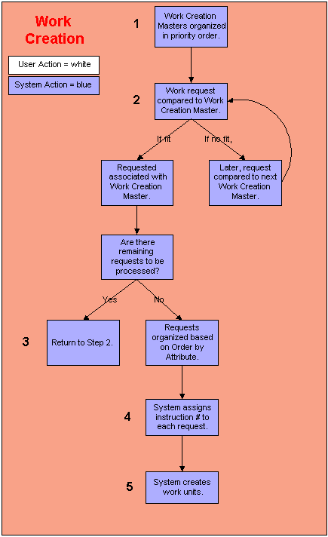

This process generates work instructions for work requests from various sources.

Step 1: The system organizes the appropriate work creation master records in priority order.
- The system determines which records it needs to retrieve, based on the process that requested work creation. The process determines why work creation was initiated. On each work creation record, the system checks the Process Field to determine if it applies.

- The system organizes the appropriate work creation master records based on priority number.

  - After the system determines which records can be applied to the work requests, the system organizes them in priority order. The priority number is defined on the work creation master record. The lower the priority number, the sooner the record is used to process work requests.

Step 2: The system compares each work request to the first eligible work creation master record.
- Based on priority, the system selects the first creation master record that it will compare to the work requests.

- The system references the work criteria record associated with this work creation master. The work criteria record defines which work requests can be processed using the work creation master record.

  - If the request does meet the criteria defined on the work criteria record, the system will associate it with the work creation master record. This request will not be reviewed by the next work creation master: it is 'reserved'. The system will compare the remaining requests to this work creation master record.

  - If the request does not meet the criteria defined on the work criteria record, the system temporarily holds the request. It retrieves the next request and attempts to process it using this work creation master record. After the system has processed through all of the requests, it will compare the 'declined' request to the next work creation master record.

Step 3: The system organizes the requests based on the order by attributes on the work criteria record.
- The system checks the attributes defined on the Order By Tab on the Work Criteria Record. It organizes the requests based on the values defined on this tab.
- For example, assume the tab contains the following value: Shipment ID, Ascending Order. The system will organize the requests in shipment ID order, with the lowest ID number first.

- If multiple values are defined on the tab, the system will further organize the requests within the first attribute. For example, in the screen diagram below, each of the requests would be organized in Shipment ID order, ascending. So, all requests for Shipment ID 1 would be ordered before all requests for Shipment ID 2. Within each Shipment ID, the details are further organized in pick location order, ascending. So, requests for location 100-100-001 are ordered before requests for location 100-100-002. Finally, within each location, the requests are organized in item number order, ascending.

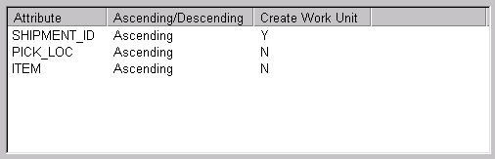

Note that this screen diagram is from the Order By Tab on the Work Criteria Window.

Step 4: The system assigns instruction numbers to each detail and generates work units.
- The system processes through the detail records in the order created during Step 3.

- Each request becomes a detail. Each detail is assigned a work instruction number. This is an internal number that identifies the detail to the system.

- The system determines which estimated work rate record it can apply to each instruction. It uses this record to calculate how long it will take an employee to process the instruction.

Step 5: The system creates work units.
- The system references the work creation master record to determine how to create the work unit. Note that when the work is replenishment work created out of the wave process, and the "Wave Replen Work Type" setting (on the Work System Values Window) is activated, the system will use this special replenishment work type instead of using the work type as defined on the work creation master.
- When the system reaches the work unit break, it creates a work unit. The work unit is assigned an instruction number. The work unit groups together all instructions that will be assigned to one employee.

- If the Auto Print Checkbox on the Work Creation Master Window is selected and this work unit was created for an outbound process, the system will print the pick list as soon as the work unit is created.

- For order picking, work units are often created at the order or shipment number level. For batch picking, work units are often created at the pick location level.

Work Execution Flow Diagram...

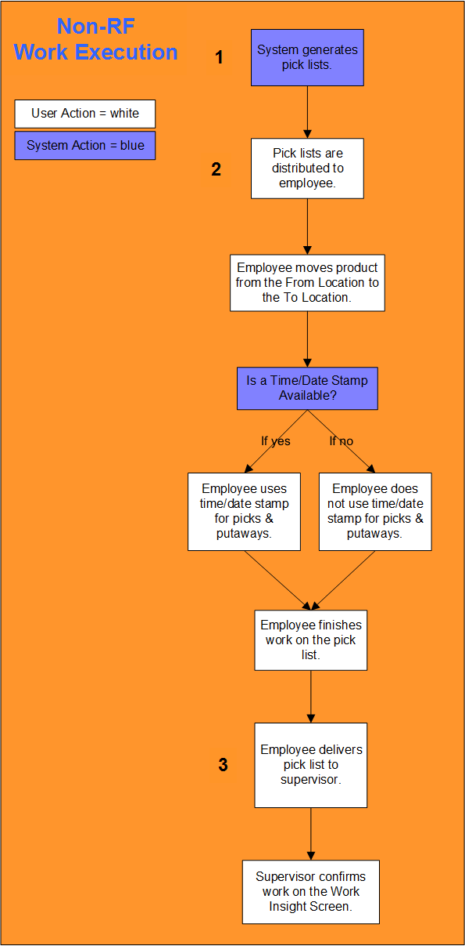

Non-RF Work Execution
The work execution process occurs when employees obtain the product required to fullfill customers' shipment requests. The work units processed during work execution were generated during work creation. Work that is not executed on an RF device is typically completed from pick lists. The procedures below provide a general method for executing Non-RF work; since system intervention is minimal, the actual procedures are based on your business practices.

Step 1: The system generates the pick lists.
- Pick lists are generated at the work unit level. To system references the work criteria record to determine which instructions are included in the pick list.

- The following values are defined on the pick list:

  - Work Unit Number

  - Team (if applicable)

  - From Zone

  - From Location

  - To Zone

  - To Location

  - Item # / Description

  - Quantity

  - Order Number

  - Order Line Number.

Step 2: A manager distributes the pick lists to the appropriate personnel.
- Employees will obtain product from the From Locations and deliver it to the To Locations. They will record the check digit associated with each location visited. If applicable, they will use a time/date stamp to indicate when product was picked and putaway.

Step 3: An administrator confirms the work activity on the Work Insight Screen.
- After the employee has processed the work on the pick list, he/she will deliver the pick list to the data administrator responsible for entering work activity in the system. Note: The user and warehouse must have access to a work profile that supports the work type and work zones on the work instruction.

- The data administrator will use the Work Insight Screen to indicate what work activity occurred on the floor. He/she will complete the following activities:

  - Identify the person who processed the work unit.

  - Identify when the product was picked and putaway in the Start Time/Date and End Time/Date Fields (if a time/date stamp was used).

  - Identify the check digits associated with the From Location and the To Location.

  - Identify the quantity picked.

  - If appropriate identify why a short pick or other irregular activity occur.

  - Confirm the work.

- Once the work is confirmed, the system will change its status to Ready for Packing.

  - If you have created additional status between In Picking and Ready for Packing, the unit will change to the next appropriate status.

RF Work Execution Flow Diagram...

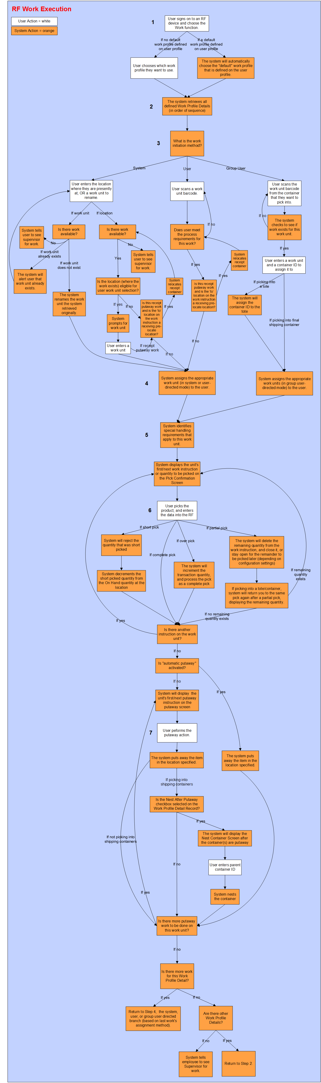

RF Work Execution
The work execution process occurs when employees obtain the product required to fulfill customers' shipment requests. The work units processed during work execution were generated during work creation.

Step 1: The employee signs on to an RF device. The system determines which work profile to associate with the employee
How an employee can work is determined by the work profile record associated with his/her user sign on. When the employee signs on to an RF device (and chooses the Work function), the system will determine how he/she should process work. The system uses the following process to select the appropriate work profile:
- First, the system will reference the employee's user profile. If a work profile is defined as the "default work profile"on his/her user profile, the system will assign this profile to the user. The system will not continue to step B.
- However, if the employee's user profile does not have a work profile associated with it, the system will prompt with work profiles that are user and warehouse authorized.

Step 2: The system retrieves the user's existing work profile detail record(s)
- The system can only assign those work instructions that match a detail record on the user's assigned work profile. It looks for the following fit:
- The work instruction's work type must match the work type on the work profile.
- The work instruction's work zone must accept the equipment type defined on the work profile detail record.
Note that if none of the detail records match the work instructions, the system will display a message requiring the employee to obtain work from a supervisor.

Step 3: The system will determine the method of work initiation: the system or the user?
- If the system should initiate work, the user will scan the nearest location barcode. The system will assign the work unit closest to this location. The employee will identify the work unit with an arbitrary barcode.
System-Directed Work Unit Selection: If the from location (where the system assigned you a work unit) is eligible for system-directed work unit selection, then the system will display an additional initiation screen. This allows you to choose the work unit you wish to execute. All the work unit validations for this system-directed work unit selection screen are identical to the validations that the system performs when initiating work with the user-directed initiation screen (such as the work unit cannot be closed, cannot be active, etc).
- If the user should initiate work, he/she will determine which work unit should be processed first. He/she will scan the work unit's barcode, usually from the pick list generated during work creation. Note that "Group user" work can also be initiated, which allows you to consolidate container picks. For more detailed information on executing group-user work, see the topic Processing RF Work (Group User section)
- If starting receipt putaway work from RF for a receipt container and the To location on the work instruction is the receiving pre-locate location, then the system will relocate the receipt container.

Step 4: The system will assign the appropriate work unit to the employee
- Within the work unit, instructions are assigned based on the From Assign Method Field on the work profile detail record.
- Within the work unit, the system assigns work summaries, not work instructions, to the user.

Step 5: The system applies any special handling constraints to the work unit; system displays instruction/quantity to be picked
The system references the Work Special Handling Constraints Window to identify unique handling requirements for this work unit. A special handling constraints record determines the following:
- When additional handling constraints are required. These constraints can be set for any of the following characteristics:
- Per Item / Company
- Per Account / Company
- Per User Profile / Work Zone / Work Type
- If constraints are required, the system will determine what type of constraint is used. Any combination of the following constraints can be used, including:
- Employee must identify the pick location by scanning the location number or its check digit number.
- Employee must verify the item quantity that he/she is processing.
- A maximum quantity pickup set to minimize breakage or loss.
- The ability to override the location, lot, or license plate data for specific work instructions.
- System then displays the work unit's first/next work instruction, or the quantity to be picked (after performing a partial pick action), in the Pick Confirmation Window.

Step 6: The user picks the product
Next, the user picks the product, and enters the appropriate data into the RF device.
- If the user performs a complete pick, the system will process the pick.
- If the user performs a short pick, the system will reject the quantity that was short picked, and decrement the short picked quantity from the On Hand quantity at the location.
- If the user performs a partial pick, the system will delete the remaining quantity from the work instruction, and close it, if the "Close on Partial Pick" checkbox (in Work Special Handling Window) is selected. If not, the system would keep the instruction open so the remainder could be picked later. Note that the "partial pick and close" action is only available for RF replenishment and work order picks if it is defined to do so in the Work Special Handling Window. If you are partial picking into a tote or shipping container, the system will return you to the same pick again after a partial pick, displaying the remaining quantity that is yet to be picked. The system will repeat this action until the whole quantity is picked. This is helpful if you cannot fit a complete pick into one tote/container.
- If the user performs an over pick, the system will increment the transaction quantity, and process the pick as a complete pick. Note that this action is only available for RF replenishment and work order picks if it is defined to do so in the Work Special Handling Window.
After the pick processing is completed:
- The system will display the work unit's first/next putaway instruction.
OR
- The system will automatically putaway the work unit's item, if the Select After Putaway Checkbox was selected on the current user's work profile record. This would bypass having to manually putaway the item. Typically, this setting would be used when you are picking directly into shipping containers (but you can use it in any work scenario).

Step 7: The user performs putaway.
The user will putaway the item quantity at the appropriate location. Note that if your work profile is defined to putaway into shipping containers, and you are putting away to a put-to-store location or the shipping dock, you will need to provide the container ID that you are putting into. Also, if this is a new container, you will need to indicate the container type. After the user performs the putaway action on the item, the system will putaway the quantity in the specified location. If the user's work profile indicates that they should nest container(s) after putaway, the system will display a screen to perform this action. The system will also check to see if there is any more putaway to be completed for this work unit. If there is, the next instruction will be displayed. If not, the system will check to see if there is any more work for this work profile detail.

Picking Management Flow Diagram...

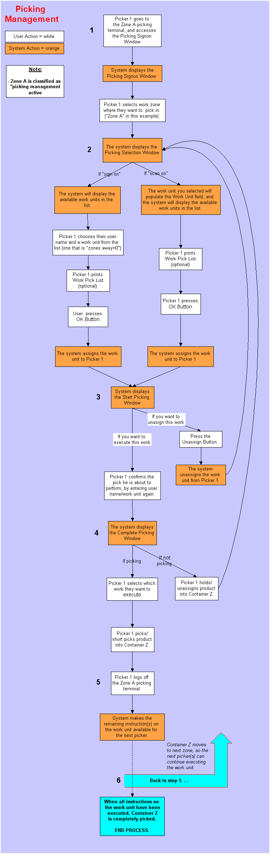

System Directed Work Flow...

